**Assignment 6.1**

**Problem​ ​Statement​ ​1:**

**You survey households in your area to find the average rent they are paying. Find the**

**standard deviation from the following data:**

**$1550,​ ​$1700,​ ​$900,​ ​$850,​ ​$1000,​ ​$950.**

**Note:​ ​Solution​ ​submitted​ ​via​ ​github​ ​must​ ​contain​ ​all​ ​the​ ​detailed​ ​steps.**

**Ans:**

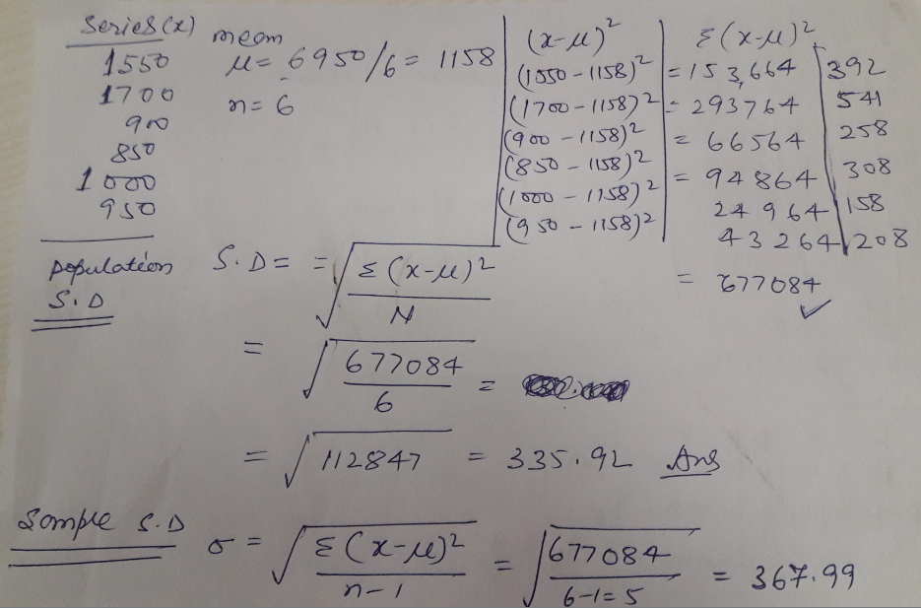

**Standard Deviation is 367.99 for Sample.**

**Standard Deviation is 335.92 for Population.**